Smart Waste Management System For Metropolitan Cities

**ARCHITECTURE**

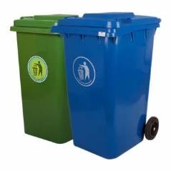

**Sensors**



**Data analytics**

**Smart Garbage Bins**



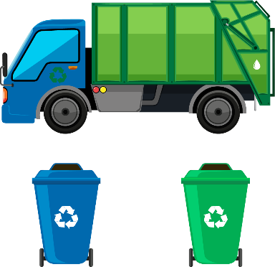

**Garbage Truck User Manager**

**CLOUD IBM**